“**AUTO-ML**”

***A Minor Project Report submitted to***

***Rajiv Gandhi Proudyogiki Vishwavidyalaya, Bhopal***

***in partial fulfillment of the requirements for the award of***

***Degree of***

**Bachelor of Engineering**

in

Computer Science and Engineering

### ***by***

## **Ashpreet Singh Chawla(**0832CS151028**)**

## **Ayush Patidar (**0832CS151034**)**

**Bhupendra Singh Tomar(**0832CS151037)

***Under the guidance of***

**Prof. Mr. Nandkishore Sharma**

**(Asst. Professor)**



**Session: 2018-19**

**Department of Computer Science & Engineering**

**Chameli Devi Group of Institutions, Indore**

**452020 (Madhya Pradesh)**

**1**

**DECLARATION**

We certify that the work contained in this report is original and has been done by us under the guidance of my supervisor(s).

1. The work has not been submitted to any other Institute for any degree or diploma.
2. We have followed the guidelines provided by the Institute in preparing the report.
3. We have conformed to the norms and guidelines given in the Ethical Code of Conduct of the Institute.
4. Whenever we have used materials (data, theoretical analysis, figures, and text) from other sources, we have given due credit to them by citing them in the text of the report and giving their details in the references.

#### Name and Signature of Project Team Members:

|  |  |  |  |
| --- | --- | --- | --- |
| **Sr. No.** | **Enrollment No.** | **Name of students** | **Signature of students** |
| 1. | **0832CS151028** | **Ashpreet Singh Chawla** |  |
| 2. | **0832CS151034** | **Ayush Patidar** |  |
| 3. | **0832CS151037** | **Bhupendra Singh Tomar** |  |

**2**

**CHAMELI DEVI GROUP OF INSTITUTIONS, INDORE**



**CERTIFICATE**

Certified that the project report entitled, “**AUTO-ML**” is a bonafide work done under my guidance by Mr. NandKishore Sharma in partial fulfillment of the requirements for the award of degree of Bachelor of Engineering in Computer Science Engineering.

Date: _________________________

(Mr. Nandkishore Sharma )

Guide

__________________________ _________________________

(Prof. Shailendra Kumar Mishra) (Dr. K.S. Jairaj )

Head of the Department Dean, CDGI

__________________________ _________________________

(Internal Examiner ) ( External Examiner )

3

­

## **CHAMELI DEVI GROUP OF INSTITUTIONS**

## **INDORE**

**ACKNOWLEDGEMENT**

We have immense pleasure in expressing our sincerest and deepest sense of gratitude towards our guide Mr. Nandkishore Sharma Gupta for the assistance, valuable guidance and co- operation in carrying out this Project successfully. We have developed this project with the help of Faculty members of our institute and we are extremely grateful to all of them. We also take this opportunity to thank Head of the Department Mr. Shailendra Kumar Mishra, and Dean of Chameli Devi Group of Institutions, Dr. K.S. Jairaj, for providing the required facilities in completing this project. We are greatly thankful to our parents, friends and faculty members for their motivation, guidance and help whenever needed.

#### Name and signature of team Members:

1. Ashpreet Singh Chawla
2. Ayush Patidar
3. Bhupendra Singh Tomar

**4**

**TABLE OF CONTENTS**

|  |  |
| --- | --- |
| CONTENTS | Page No. |
| Title Page |  |
| Declaration | 1 |
| Certificate by the Supervisor | 2 |
| Acknowledgement | 3 |
| [Abstract[1]](#__RefHeading___Toc512792602) | 7 |
| Chapter 1: Introduction  1.1 Rationale  1.2 Goal  1.3 Objective  1.4 Methodology  1.5 Role  1.6 Contribution of Project  1.6.1 Market Potential  1.6.2 Innovativeness  1.6.3 Usefulness  1.7 Report Organization  Chapter 2: Requirement Engineering  2.1 Requirement Collection  2.1.1 Brainstorming  2.1.2 Literature survey  Chapter 3: Analsis & Design  3.1 Use-case Diagrams  3.2 Activity Diagrams  3.3 Sequence Diagrams  3.4 Class Diagrams xxvii  3.5 Data Design xxviii  3.5.1 Schema Definitions xxviii  3.5.2 Integrity Constraints xxx  3.6 ER diagram………………………………………………………………………………………………………………  3.7 System Working…………………………………………………………………………………………………  Chapter 4: Construction i  4.1 Implementation xxxvii  4.1.1 Implementation Details xxxvii  4.2 Testing xxxvii  4.2.2 Unit Testing i  4.2.3 Blackbox………………………………………………………………………… | 8  8  9  10  12  12  12  14  14  14  14  14  15  16  16  16  16  19  19  21  26  28  29  30  31  37  38  39  40  41  41  42  42  43 |
| Chapter 5: Conclusions and Future scope of study  Appendix | 47  48 |
| References | 53 |

**ABSTRACT**

There are various kinds of events that are being held across the nation. Many of them don’t get a major exposure or big participation due to lack of promotion tactics. Most of the promotions are done on social medias and some particular apps and websites only and rest are paid promotions. But the reach is still limited as the interested people are not notified in -person and many remain uninformed.

To overcome this problem, Event mania is being proposed.

By surveying already available services for the same (including Facebook, book my show, All events.in), we concluded that these services have a limited no. of event list, and also not entire details of the same are available, at the same time, the user needs to revisit the page again and again to get the updates.

Event Mania has a sorted list of various events that are being organized across the country and listing them category wise to the user on the basis of the categories selected by the user. Thus, providing an easy access to the desired kind of events to the user. The website also provides the platform to post the events under a tagged category to the user thus, promoting the event to the right audience.

Thus, event mania provides a common platform to both the host and participants of various events organized across the country, providing a vast exposure (to the event) on a single platform and, on hand information (to the interested audience).

**Chapter 1**

* 1. **INTRODUCTION**

Promotion of various kinds of events is an important part of any event hosting process as it leads to maximum participation of audience.

Event mania provides a unique platform for the promotion of different kinds of events to the interested audience in a cordial and thus, easily accessible manner by the right audience thus, increasing the chances of participation.

1**.2 RATIONALE**

Currently, there are no particular services that provide a precise information about any event organized. They usually do not have any sorted manner for the same. Also, only a selected or few events are being listed. Thus, the interested person either needs to enter name manually of the particular event they are looking for (which they are aware of) else, they get informed from a mutual source only.

Event mania provides a user-friendly access for the same by allowing its users to add categories of their interest (categories including literature, sport, cultural and many more) to list out the entire events under the same tag across any part of the country. Thus, making the search more sorted, more user friendly.

Thus, providing a big exposure and promotion to right audience; ensuring a better chance of mass participation.

**1.3 GOAL**

The goal of the project is to address a revolutionized access to acquaint oneself with all the possible events that are being held across the nation and at the same time promotion of one’s event to the right or targeted audience from around the country. Hence, replacing the old hectic method

To do this:

* We propose a faster solution by redefining the traditional method of accessing the events by sorting them into categories and thus providing the requested information in a precise manner. The recommendations for similar interest increases the chances of reaching a vast audience from host’s point of view

**1.4 OBJECTIVE**

The objective of the works is to propose options for replacing the traditional long and tire some practice of searching events manually along with promoting events in an appropriate and less troubled manner.

To do this it requires to:

* Review and study different event promoting methods that are available in the market. This includes Facebook events, Bookmyshow, Allevents.in, townscipt.in.

The main drawback found in:

1. Facebook events: they are accustomed to a selected audience who have basically bookmarked the particular event. Furthermore, the related friends of the person get informed about the event, but not more than that.
2. Book my show: here, only a few categories of events including sports, plays and a few parties are available that too, you need to visit the page regularly.
3. All events.in: here, although, the area selected on the spot by the user, leads to the information of various events available in the place along with the online ticket booking facilities, there are no further details or suggestions available regarding the interest of the user.
4. Thus, here we find that, although the above services are providing the direct details and updates of the selected events there are no further exposures and also the user needs to visit the selected page time and again to get details and updates.

The difference that we have from these services are as follows:

* We provide a facility of manually selecting a list of categories of events, so as the user gets information only about the type of events they are interested in.
* This allows event mania to recommend further events by tracking users with mutual interests. Thus, promoting new events from other categories by another user and then too not making it crowded.
* The user can easily access the event they have an interest in by adding it to their favorite list
* Provide effective solutions to promote your event by categorizing it under the right tag so as to attract the targeted audience.
* Provide simpler ways to look up for events other than your selected category anywhere across the nation in the explore section.
* Accurate information of the events to the audience by providing the contact details of the host so as to avoid confusions.
* Allowing the host to have a check on the popularity of event by providing the ‘like’ option.
* Authentication of the events before posting them on the web application is manually done by our admin so as to avoid any fraud or malpractices.
* User are also provided with the search option so as to find out the exact event they want to look for.
* Notification about the events’ authentication allows the users to have a proper check on what are their posts up to.
* The simple access to get the history of ones’ posted events by exploring ‘my events’ provides a handful access to all the events that the user has posted till date.
* Manual updating of profile is also provided to the user to make any changes in personal information at any point of time

Thus, making the platform very user friendly and easily accessible.

**1.4 METHODOLY**

We have used iterative waterfall model for our system. Since we already had our requirements set and resources available. So, we only had to design & develop the product followed by testing and implementation of the product. Thus, error, if any, found, were fixed by iteration.

After completing a single step, by following the iterative waterfall model’s rule, we tested and implemented it; if no error was found. If found, we iterated back from the previous steps and restarted the steps. Thus, correcting and fixing the errors at the same time and then implementing it.

Software development is a set of steps comprise of method, tools and procedures. These steps are referred to as Software Engineering Paradigms. Among at the paradigms evolved over the year and documented, which paradigm is most suitable, depends on the nature of project – the type of application, the tool proposed to be used and the kind of controls and documentations that would be required.

The Software Engineering Paradigm applied to the project is **ITERATIVE WATERFALL MODEL.** The Iterative Waterfall model combines elements of the waterfall model applied in an iterative fashion. The Iterative process model, like prototyping and other evolutionary approaches, is iterative in nature. But unlike prototyping, the Iterative Waterfall model focuses on the delivery of an operational product with each increment.

This model is chosen as the satisfaction of customers do not have to wait until the entire system is delivered Customer can use the early increments as a form of prototype and gain experience which informs the requirements for the later increments and the overall risk of project with this model is very low.

**Iterative Waterfall model basically consist of five general phases:**

**Analysis:** The requirement gathering process is intensified and focused specifically on software. Requirements for both the system and the software are documented and review with the customer.

**Design:** Software design is actually a multi-step process on four distinct attributes of a program: data structure, software architecture, interface representation, and procedural detail. The design process translates requirements into a representation of the software that can be assessed for quality before coding begins.

**Coding:** The design must be translated into a machine-readable form. The code generation step performs this task. If design is performed in a detailed manner, code generation can be accomplished mechanistically.

**Testing:** Once codehas beengenerated, program testing begins. The testing process focuses on the logical internals of the software, ensuring that all statements have been and on the functional externals.

**Support:** Software will undoubtedly undergo change after it is delivered to the customer. Changes will occur because errors have been encountered because the software must be adapted to accommodate changes in its external environment.

Thus, in this way we applied the iterative waterfall model method to achieve our objective.

**1.5 ROLE**

The work done by group members in the above mentioned entitled project are as follows-

## Akanksha Vyas: Front End, Testing, Documentation, designing and analysis

Anshul Raj Bhangre: software developer, back end coding, database

Ayush Patidar: Software Developer, machine learning, database

Charu Gupta: Front End, Documentation, designing and analysis

**1.6 CONTRIBUTION OF PROJECT**

**1.6.1 MARKET POTENTIAL**

* **Market size**: Since our product is mainly set for Indian market, we have a population of around 130 crores and counting. out of these, 50% to 65% of the population are youth.

Since, most of the events are youth oriented (both organized as well as attended), there is a big market size that would be attracted to our service. Also, the rest of the population including the middle-aged ones are not the left-out groups as many of them are interested in most of the events organized, some child-based activities are also organized now a day, and also a few programs for old aged people are also held. thus, we have most of the categories covered under our service. And market size also covers 70%-80% of the population for sure.

* **Market growth** **rate**: As there is no precise service regarding the same is available right now. we target a good market growth rate.
* **Profitability:** since it’s a free to access application we need to balance our profitability by ensuring right ads. since its free we will have a maximum user coverage.
* **Competition**: the major competition in the present market includes: Facebook events, Bookmyshow, AllEvents.in, townscript.in. As stated earlier, they do not have a precise manner for the same service. we have a potential of tough competitions to these well-established services as well.
* **Product and consumer type**: we cover consumers from all age groups and backgrounds.

**1.6.2 INNOVATIVENESS**

Innovativeness of our product can be seen from the following features:

1. Every type of category in events are included (no exclusions)
2. Frequent recommendations help user explore more events.
3. Recommendations also increases the audience of a particular event.
4. Easy access to favorite event that increase the chances of revisiting the event and thus chances of participation increases.
5. Better than the currently available services as the entire coverage of all events is done in a sorted manner, thus is user friendly.
6. Free of cost and user-friendly access.

**1.6.3 UNIQUENESS**

### **Usefulness:**

Events now-a-days are not just for fun and entertainment but also moneymaking methods. People do not organize these mega gala events just fur fun. The right kind of promotion increases the chance of mass participation. thus, more profitable for the organizers. From audience’ point of view, we see that people are excited to join and attend these gala events to either relive from work stress or to learn something new or to socialize. Thus, they look up for such events.

So, Event Mania is useful to both the host as well as the audience.

**1.7 REPORT ORGANIZATION**

**Chapter 1** explains introduction, rationale, goal, objective, methodology, role, contribution of project, market potential, innovativeness, usefulness.

**Chapter 2** discusses about the requirement Engineering. such as functional, non-functional requirements, hardware and software requirements.

**Chapter 3** gives the details of the requirement analysis and design such as use case, sequential, activity and class diagrams along with system architecture.

**Chapter 4** explains how system is implemented along with its implementation details with the architecture diagram and also information about the testing performed.

**Chapter 5** discusses about conclusion and future work.

**Chapter 2**

**REQUIREMENT ENGINEERING**

The requirement engineering include the Functional and Non-Function requirements, and Hardware and Software requirements. The functional requirements are the activities that admin performs with the request checking section and the database interactions. The non-functional requirements includes feasibility, reliability, scalability. The hardware requirements is inclusive of the RAM, hardisk and details about processor etc . The software requirements include the programming languages like MySql, JAVA.

**2.1 REQUIREMENTS**

## 

## 2.1 **Requirement Collection**

Requirement collection for event mania was done by the following methods:

1. **Brainstorming:** we all the group members had a few brainstorming sessions regarding the present problems with these promotions of events and also the access to these aspired events by one. We came up with so many raw ideas which then formulated to get up to the idea of creating event mania.

2**. Literature survey**: we studied and analyzed various applications that are already available in the market. These includes: Facebook, Bookmyshow, Allevents.in, Township.in. We found out the drawbacks that they have and the services they are lacking and tried to overcome all of them in our application.

**HARDWARE REQUIREMENTS:**

RAM(2GB), hardisk 8GB, OS windows 10,I3 processor.

**SOFTWARE REQUIREMENTS:**

webserver-tomcatt, glassfish

web browser- chrome, Firefox

**Programming Technology: -**

**Java**: We are using java as our development platform language, since it is the new upgrading technology and gives a large set of rule or instructions, which is easy to implement the system.java also provide a better database creation facility and connectivity with the system.

**python:**

The machine learning section for the recommendation part has been programmed using python.

**Html -css**

For the designing swction for the front end, we have used html with css.

**2.2 REQUIREMENT COLLECTION**

**FUNCTIONAL REQUIREMENT**

1.**Interface Requirement -**

The system is capable to process various activities as per selected by the user according to their requirements.

2.**Audit Trail -**

For each activity, the data will be recorded in the application’s varied section as

per accessed by the user.

3.**Capacity -**

The system is enough capable to hold the data and process on it.

**NON-FUNCTIONAL REQUIREMENT**

1. **Maintainability:**

Human resources are least required to maintain the components. And is not required to collect the raw data from each of the components.

2. **Reusability:**

The components are compatible for changing environment and supports upgradeability.

3. **Availability:**

The system is functional throughout and data transfer takes place only when user requests.

4. **Usability:**

The system is user friendly as it uses a simple method to enhance all the activities required by the user.

5. **Reliability:** The system is highly consistent and reliable

**CHAPTER 3**

## 3.1 **Use-case Diagrams**

The user can register for event mania after which he has to login the application. They can select a list of favorite categories of events of which they would be notified later. They can post events of their own and can view events they are interested in. The admin on the other hand can also login and check the request to post any event. Both user and admin can log out of the account.

Use case diagram of event mania:

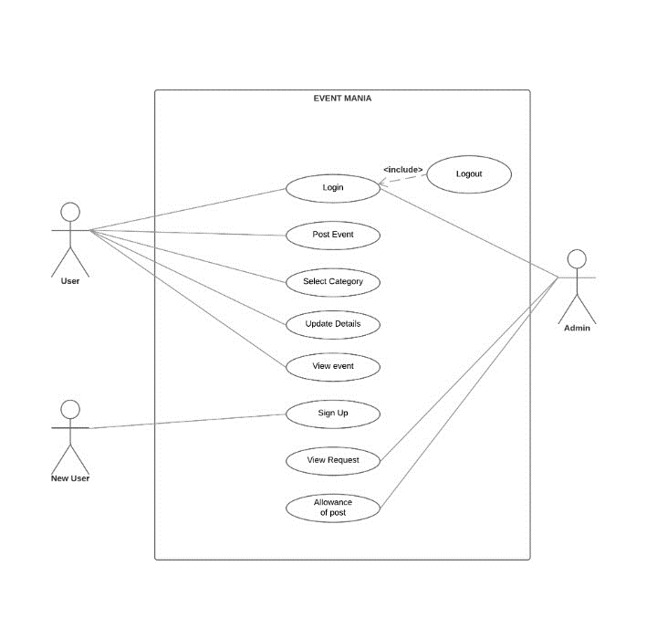

**Figure 0.1: Use-case Diagram of <<event mania>>**

## 

## 3.2 **Activity Diagrams**

The activity diagram of login registration gives an in brief details of activity flow for the same. Here, we see that the starting is done by checking weather the person is a registered user or not. If yes, he is asked to login by providing login details else he needs to register first followed by selecting a list of various categories available directing then to the home page of the application.

Next, the activity diagram for admin page has the same procedure for log in by authentication and then the admin has the activity for either checking the requests and allowing or rejecting them and also check the previous activities done by admin all leading to log out once done.

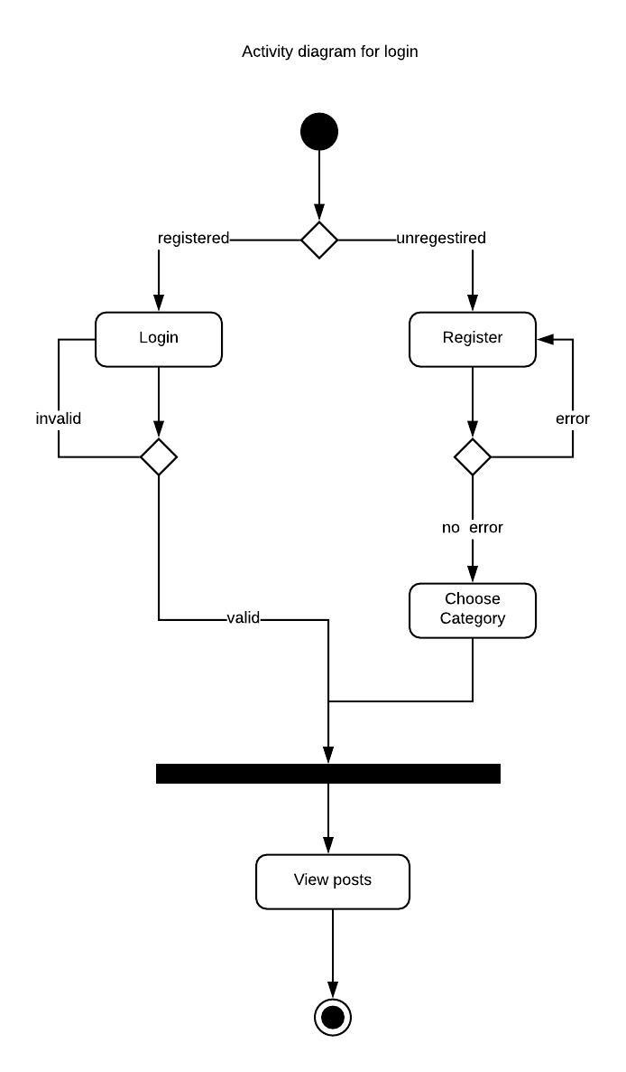

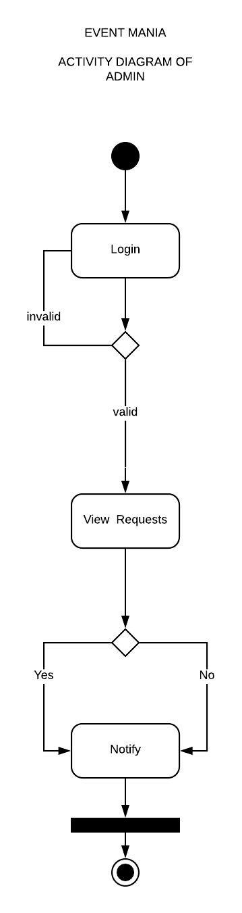

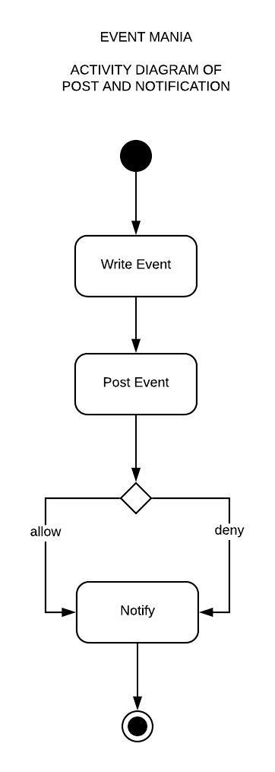

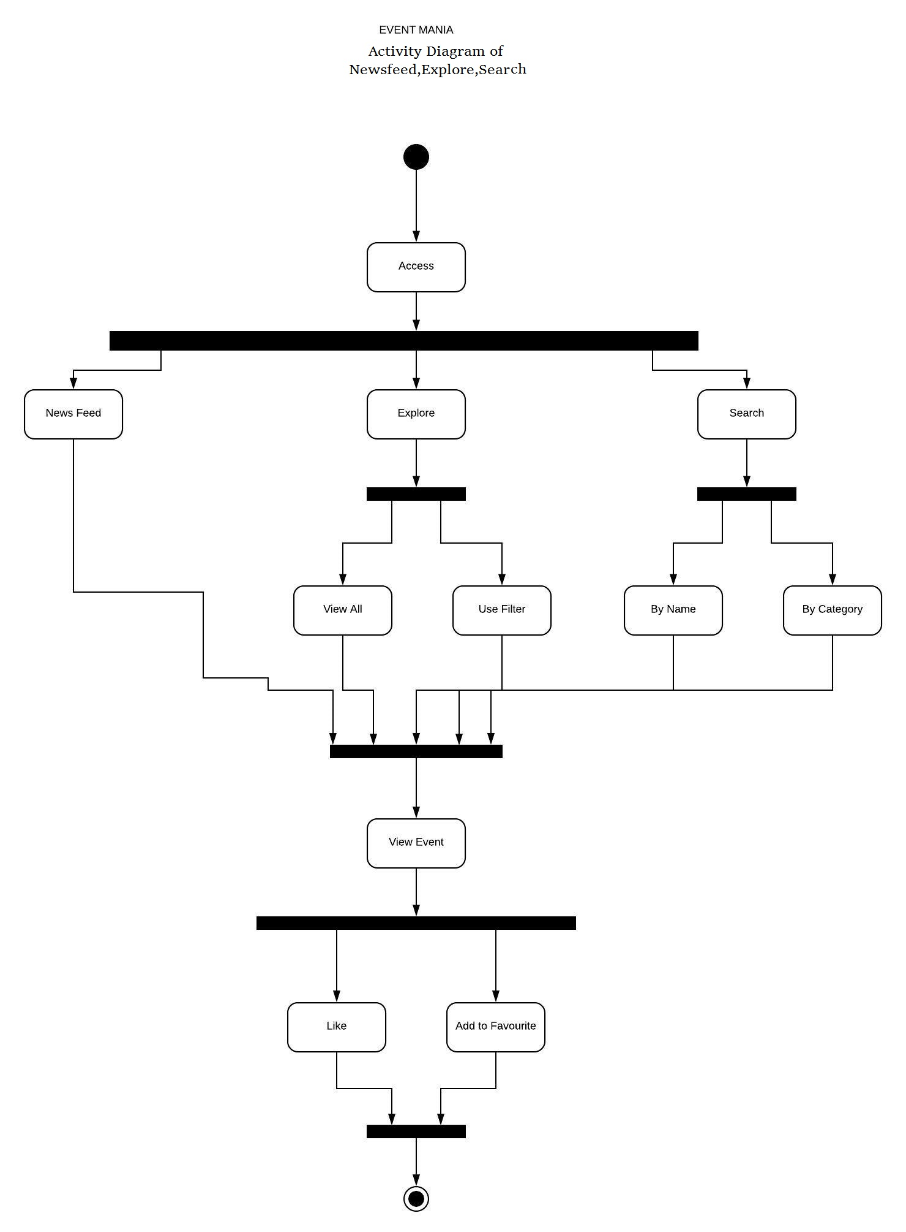

**Figure 0.2: Activity Diagram of the <<profile>>**

**3.3 Sequence Diagrams**

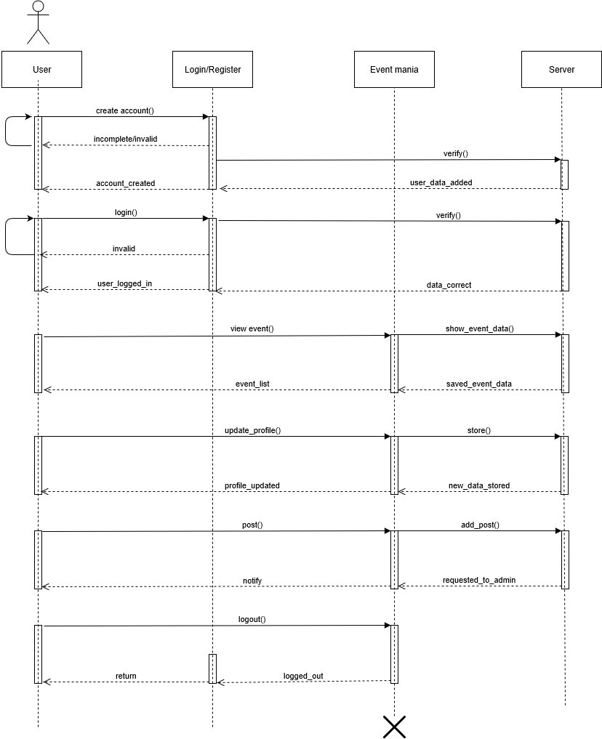

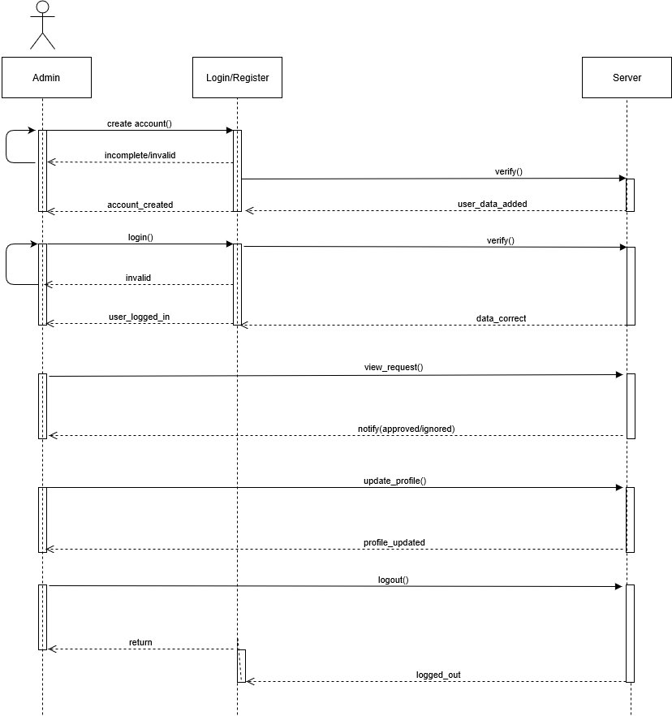

## **3.4 Class Diagrams**

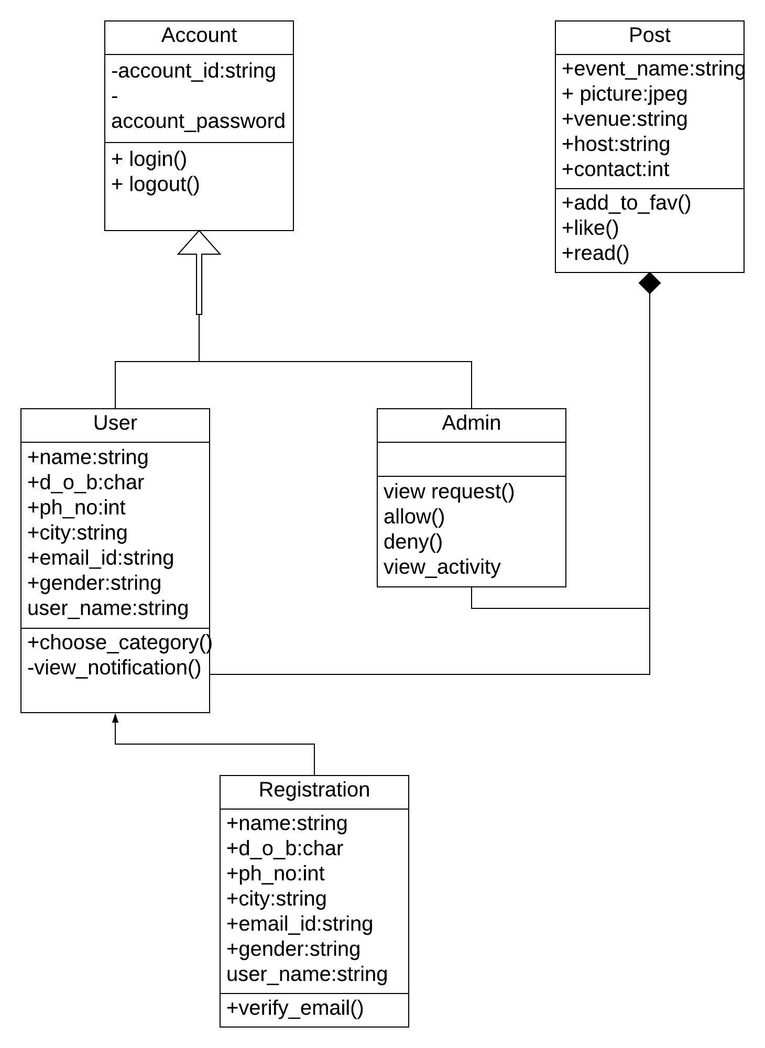

## **3.5 Data Design**

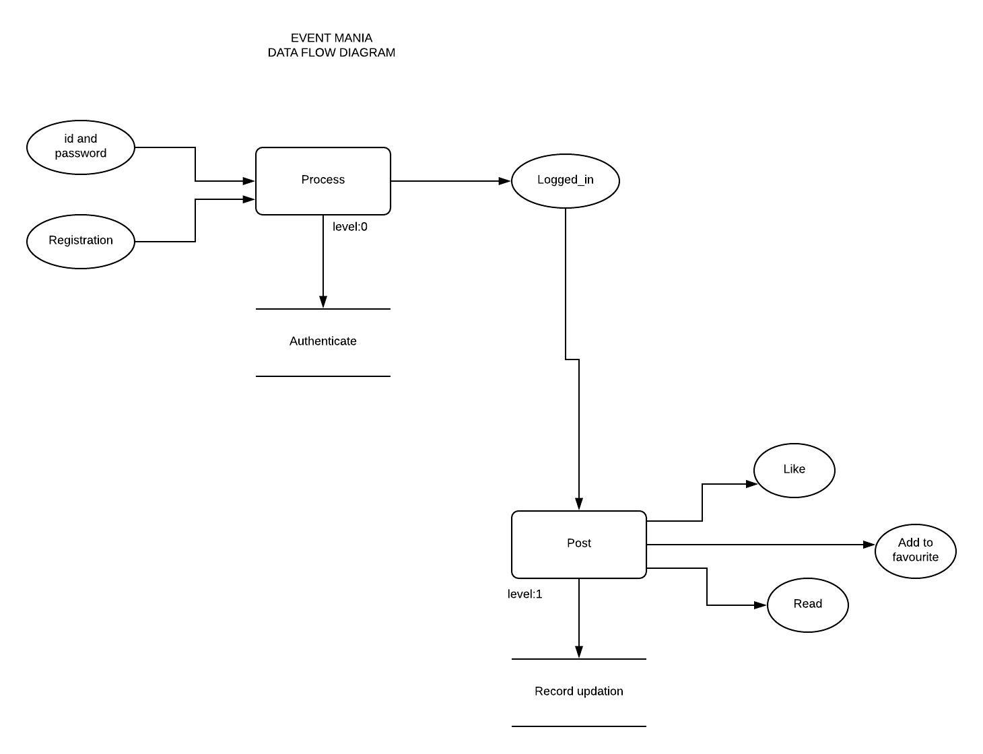

### **3.5.1 Schema Definitions**

**Table 0.1: Schema for <<User>>**

|  |  |  |  |  |
| --- | --- | --- | --- | --- |
| Field | Type | Null | Key | default |
| User id | Varchar(51) | No | PRI | NULL |
| Password | Varchar(51) | No |  | NULL |
| Confirm password | Varchar(51) | No |  | NULL |
| Name | Varchar(51) | No |  | NULL |
| Dob | Dob | Yes |  | NULL |
| Gender | Varchar(6) | No |  | NULL |
| Email | Varchar(51) | No |  | NULL |
| Mobile | Varchar(10) | No |  | NULL |
| City | Varchar(51) | No |  | NULL |
| State | Varchar(51) | No |  | NULL |
| Etype 1 | Varchar(51) | Yes |  | NULL |
| Etype 2 | Varchar(51) | Yes |  | NULL |

**Table 0.2: Schema for <<Event>>**

|  |  |  |  |  |
| --- | --- | --- | --- | --- |
| Field | Type | NULL | Key | Default |
| Ecode | Int (11) | No | PRI | NULL |
| Userid | Varchar(51) | No |  | NULL |
| Ename | Varchar(51) | No |  | NULL |
| Etype | Varchar(51) | No |  | NULL |
| City | Varchar(51) | No |  | NULL |
| Edate | Date | No |  | NULL |
| Etime | Time | No |  | NULL |
| Edesc | Longtext | No |  | NULL |
| Eposter | Longblob | No |  | NULL |
| Proof | Longblob | No |  | NULL |

**Table 0.3: Schema for <<like>>**

|  |  |  |  |  |
| --- | --- | --- | --- | --- |
| Field | Type | NULL | Key | Default |
| Userid | Varchar(51) | No | PRI | NULL |
| E1001 | Int(1) | Yes |  | 0 |
| E1002 | Int(1) | Yes |  | 0 |
| E1003 | Int(1) | Yes |  | 0 |

### 

### **3.5.2 Integrity Constraints**

**Domain integrity:**

For the user :

**1.userid:**

Length=max(51)

Datatype=varchar

NULL=cannot be null

Value is unique

**2.password**

Length=max(51)

Datatype=varchar

Null =cannot be null

Value is not unique

**3.name**

Length=max(51)

Null =cannot be null

Datatype=varchar

Value is not unique

**4.gender**

Length=max(6)

Null =cannot be null

Datatype=varchar

Value is not unique

**5.mobile**

Length=max(10)

Null =cannot be null

Datatype=varchar

Value is not unique

**6. state**

Length=max(51)

Null =cannot be null

Datatype=varchar

Value is not unique

**7.etype**

Length=max(51)

Null =can be null

Datatype=varchar

Value is not unique

**8 cities**

Length=max(51)

Null =cannot be null

Datatype=varchar

Value is not unique

**9. Dob**

Null =can be null

Datatype=date

Value is not unique

|  |  |  |  |  |
| --- | --- | --- | --- | --- |
| Field | Type | Null | Key | default |
| User id | Varchar(51) | No | PRI | NULL |
| Password | Varchar(51) | No |  | NULL |
| Confirm password | Varchar(51) | No |  | NULL |
| Name | Varchar(51) | No |  | NULL |
| Dob | Dob | Yes |  | NULL |
| Gender | Varchar(6) | No |  | NULL |
| Email | Varchar(51) | No |  | NULL |
| Mobile | Varchar(10) | No |  | NULL |
| City | Varchar(51) | No |  | NULL |
| State | Varchar(51) | No |  | NULL |
| Etype 1 | Varchar(51) | Yes |  | NULL |
| Etype 2 | Varchar(51) | Yes |  | NULL |

**For events:**

**1.ecode**

Length=max(11)

Null =cannot be null

Datatype=int

Value is not unique

**2.userid**

Length=max(51)

Null =cannot be null

Datatype=varchar

Value is unique

**3.ename**

Length=max(51)

Null =cannot be null

Datatype=varchar

Value is not unique

**4. etype**

Length=max(51)

Null =cannot be null

Datatype=varchar

Value is not unique

**5.city**

Length=max(51)

Null =cannot be null

Datatype=varchar

Value is not unique

**6 edate**

Null =cannot be null

Datatype=date

Value is not unique

**7.etime**

Null =cannot be null

Datatype=time

Value is not unique

**8.eposter**

Null =cannot be null

Datatype=longtext

Value is not unique

**9.proof**

Null =cannot be null

Datatype=longblob

Value is not unique

|  |  |  |  |  |
| --- | --- | --- | --- | --- |
| Field | Type | NULL | Key | Default |
| Ecode | Int(11) | No | PRI | NULL |
| Userid | Varchar(51) | No |  | NULL |
| Ename | Varchar(51) | No |  | NULL |
| Etype | Varchar(51) | No |  | NULL |
| City | Varchar(51) | No |  | NULL |
| Edate | Date | No |  | NULL |
| Etime | Time | No |  | NULL |
| Edesc | Longtext | No |  | NULL |
| Eposter | Longblob | No |  | NULL |
| Proof | longblob | No |  | NULL |

**For the like button**

**1.userid:**

Null =cannot be null

Datatype=varchar(51)

Value is unique

**2.e1001:**

Null =can be null

Datatype=int(1)

Value is not unique

**3.e1002:**

Null =can be null

Datatype =int(1)

Value is not unique

|  |  |  |  |  |
| --- | --- | --- | --- | --- |
| Field | Type | NULL | Key | Default |
| Userid | Varchar(51) | No | PRI | NULL |
| E1001 | Int(1) | Yes |  | 0 |
| E1002 | Int(1) | Yes |  | 0 |
| E1003 | Int(1) | Yes |  | 0 |

## **3.6 Entity Relationship Diagram**

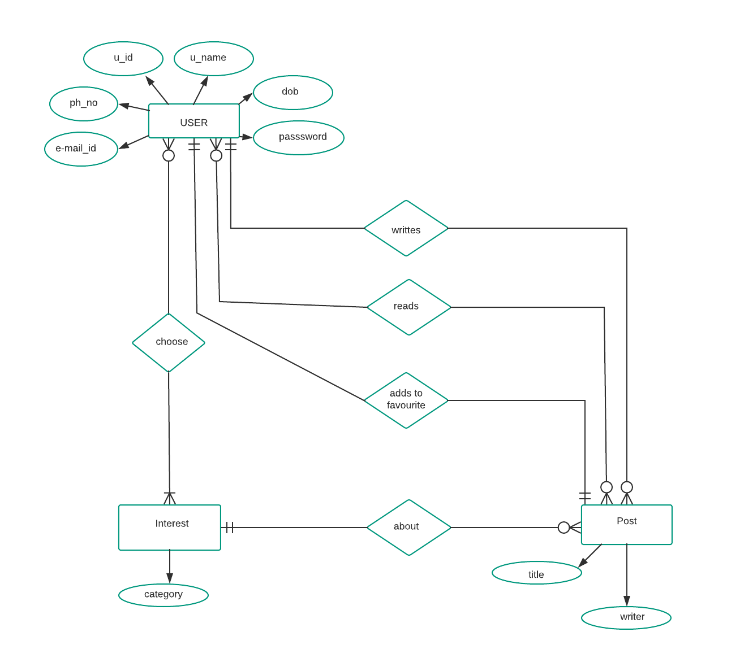

**3.6.1 SYSTEM WORKING**

1) Every user first needs to sign in or sign up first and after that he/she is allowed to select a few categories of various events available in the list.

2) All the events under the tag of their selected categories will be shown in their newsfeed.

3) When a user wants to check any event other than the ones in their favorite list, then they can look up in the explore section.

4) there is an admin available to check the validity of all the events being posted so as to be sure of right stuff being posted.

5) At the same time the user can also post any of the event that he/she wants to promote

6) the user has a facility of: liking the event leading to increase the popularity hit check, get entire details of any events they like and also add the event to their favorite list so as to access it later easily, and also to check the events posted by him previously in my events list, also there they get a complete detail of the status of their events

7) There is further option of updating profile by the user in terms of personal details and password updates.

8) finally, the user can log out anytime, once they are done.

**CHAPTER 4**

**CONSTRUCTION**

**4.1 Implementation**

### **4.1.1 Implementation Details**

#### 4.1.1.1 Software Details

webserver-tomcatt, glassfish

web browser- chrome, Firefox

#### 4.1.1.2 Hardware Details

RAM(2GB), hardisk 8GB, OS windows 10,I3 processor.

**4.2 TESTING**

**4.2.2 WHITEBOX TESTING**

**4.2.2.1 UNIT TESTING**

Unit Testing is a level of software testing where individual units/components of a software are tested. The purpose is to validate that each unit of the software performs as designed. A unit is the smallest testable part of software. It usually has one or a few inputs and usually a single output. Typically, the unit test will establish some sort of artificial environment and then invoke methods in the unit being tested. It then checks the results returned against some known value. When the units are assembled we can use the same tests to test the system as a hole.

Test Case:1 Login

|  |  |  |  |  |  |  |  |  |
| --- | --- | --- | --- | --- | --- | --- | --- | --- |
| S.No | Input | | | Actual Output | | Expected Output | | Result |
| 1  2 | UID | Password | Verified  Not verified (incorrect credentials) | | Verified  Verified | | Passed  Failed | |
| Aman | 123 |
| Aman | 546 |

Test Case:2. post event

|  |  |  |  |  |  |  |  |  |  |  |  |  |
| --- | --- | --- | --- | --- | --- | --- | --- | --- | --- | --- | --- | --- |
| S.No | Input | | | | | | | Actual Output | | Expected Output | | Result |
| 1  2 | Event admin | Event name | Event type | Host city | date | Time | Request sent to admin  Please enter event name | | Request sent to admin  Request sent to admin | | Passed  Failed | |
| Anshul | epsilon | Software | Indore | 15/04/18 | 10:00 am |
|  |  |  |  |  |  |
|  |  |  |  |  |  |
|  |  |  |  |  |  |
| Aman |  | Software | Bhopal | 15/04/18 | 10:00am |
|  |  |  |  |  |  |
|  |  |  |  |  |  |
|  |  |  |  |  |  |
|  |  |  |  |  |  |
|  |  |  |  |  |  |

Test Case:3. My favorites

|  |  |  |  |  |  |  |  |  |
| --- | --- | --- | --- | --- | --- | --- | --- | --- |
| S. No | Input | | Actual Output | | Expected Output | | Result | |
| 1.  2 | Remove | Get details | | Item removed successfully  No action take place (button broken) | | Item removed successfully  Item removed successfully | | Passed  Failed |
| Performed action on button |  | |
| Performed action on button |  | |

Test Case:4. Explore

|  |  |  |  |  |  |  |  |  |  |
| --- | --- | --- | --- | --- | --- | --- | --- | --- | --- |
| S.No | Input | | | Actual Output | | Expected Output | | Result | |
| 1.  2. | Add to favourite | Like | Get details | | Event added to favourite and like counter increased  Counter of like button did not increase | | Event added to favourite and like counter increased  Counter of like button gets increased | | Passed  Failed |
| Performed action on button  Performed action on button | Performed action on button  Performed action on button |  | |

Test Case:5. Update password

|  |  |  |  |  |  |  |  |  |  |
| --- | --- | --- | --- | --- | --- | --- | --- | --- | --- |
| S.No | Input | | | Actual Output | | Expected Output | | Result | |
| 1.  2. | Current password | New password | Confirm password | | Password changed successfully  Password mismatch | | Password changed successfully  Password changed  successfully | | Passed  Failed |
|  |  |  | |
| 123 | 589 | 589 | |
|  |  |  | |
|  |  |  | |
|  |  |  | |
|  |  |  | |
| 123 | 859 | 569 | |
|  |  |  | |
|  |  |  | |
|  |  |  | |
|  |  |  | |
|  |  |  | |

Test Case:6. My events

|  |  |  |  |  |
| --- | --- | --- | --- | --- |
| S.No | Input | Actual Output | Expected Output | Result |
| 1. | Action performed on edit button | Event edited successfully | Event edited successfully | Passed |
| 2. | Action performed on edit button | Code not found (Error 404) | Event edited successfully | Failed |

Test Case:7. Update account

|  |  |  |  |  |  |  |  |  |  |  |  |  |
| --- | --- | --- | --- | --- | --- | --- | --- | --- | --- | --- | --- | --- |
| S.No | Input | | | | | | | Actual 0utput | | Expected Output | | Result |
| 1.  2. | Full name | Dob | New email | New mobile | State | City | Information  Updated successfully | | Information  Updated successfully | | Passed  Failed | |
| Anshul | 04/11/97 |  | 9407007058 | MP | Indore |
|  |  |  |  |  |  |
|  |  |  |  |  |  |
|  |  |  |  |  |  |
|  |  |  |  |  |  |
| Anshul | 04/11/97 |  | 9407007058 | MP | Indore |
|  |  |  |  |  |  |
|  |  |  |  |  |  |
|  |  |  |  |  |  |
|  |  |  |  |  |  |
|  |  |  |  |  |  |

Test Case:8. News feed

|  |  |  |  |  |  |  |  |  |  |
| --- | --- | --- | --- | --- | --- | --- | --- | --- | --- |
| S.No | Input | | | Actual Output | | Expected Output | | Result | |
| 1.  2. | Add to favourite  Performed action on button | Like  Performed action on button  Performed action on button | Get details | | Event added to favorites and like counter increased  Counter of like button did not increase | | Event added to favorites and like counter increased  Counter of like button gets increased | | Passed  Failed |

Test Case:9. Create account

|  |  |  |  |  |  |  |  |  |  |  |  |  |  |  |
| --- | --- | --- | --- | --- | --- | --- | --- | --- | --- | --- | --- | --- | --- | --- |
| S. No | Input | | | | | | | | | Actual Output | | Expected Output | | Result |
| 1  2. | User id | Password | Confirm password | Full name | Dob | Gender | email | Mobile number | Account created successfully  Account created successfully | | Account created successfully  User id should be unique | | Passed  Failed | |
| Ayu1 | 12340 | 12340 | Ayush | 04/11/97 | male | Xxx2gmail.com | 78945613 |
|  |  |  |  |  |  |  |  |
|  |  |  |  |  |  |  |  |
|  |  |  |  |  |  |  |  |
| Ayu1 | 12400 | 12400 | Ayush | 04/11/97 | male | Xxx2gmail.com | 78945613 |
|  |  |  |  |  |  |  |  |

Test Case:10. Admin (Allow):

|  |  |  |  |  |
| --- | --- | --- | --- | --- |
| S. No | Input | Actual Output | Expected Output | Result |
| 1. | Action performed on allow button | Event gets accepted | Event gets accepted | Passed |
| 2. | Action performed on allow button | No action took place (button broken) | Event gets accepted | Failed |

Test Case:11. Admin (decline):

|  |  |  |  |  |
| --- | --- | --- | --- | --- |
| S. No | Input | Actual 0utput | Expected 0utput | Result |
| 1. | Action performed on deny button | Event gets rejected | Event gets rejected | Passed |
| 2. | Action performed on deny button | No action took place (button broken) | Event gets rejected | Failed |

**4.2.2 BLACKBOX TESTING**

**4.2.2.1 Functional Testing**

Functional Testing is a testing technique that is used to test the features /functionality of the system or Software, should cover all the scenarios including failure paths and boundary cases. Here we did a trial and error method to carry out the same.

**4.2.2.2 System Testing**

System testing of software or hardware is the testing conducted on a complete, integrated system to evaluate the system’s compliance with its specified requirements. The hardware and the software units are tested separately and then tested together to check if the desired results are obtained.

**4.2.2.3 Performance Testing**

Performance testing, a non-functional testing technique performed to determine the system parameters in terms of responsiveness and stability under various workload. Performance testing measures the quality attributes of the system, such as scalability, reliability and resource usage

**4.2.2.4 Acceptance Testing**

Acceptance testing, a testing technique performed to determine whether or not the software system has met the requirement specifications. The main purpose of this test is to evaluate the system's compliance with the business requirements and verify if it is has met the required criteria for delivery to end users. In the interface designed for the system, the POST, LIKE, ADD FAVORITE and GET DETAILS button acts as the Acceptance testing

**CHAPTER 5**

**CONCLUSION**

**Conclusion & future works:**

So, we see that Event mania overcame so many drawbacks of the present available services in the market. This is done by allowing a user to either post an event of his own (which he’s hosting) and targeting a right or interested audience that would definitely like to join the event and thus will increase the market exposure and promotion of their events. The user can also join as a spectator where he can watch and explore all types of events that seems of his interest and that too in a precise manner. This is achieved by adding all kinds of filters that suits the users’ interest and thus making it easier to access and user friendly.

Future scope of the project includes the following features:

1. Adding a payment gateway method.
2. More filters.
3. On-time location detection and recommendations for the nearby events that may interest the user.
4. Map navigation to the venue along with the cab or transport (for outskirts) bookings.
5. List of hotels or restaurant’s details that are nearby the venue.
6. List of the previous events hosted by the same host.
7. One to one chat with the admin and the host of event
8. Pictures and videos of events after their completion.
9. Trending events in recommendation.
10. Expanding the regions from India to cross borders as well.

Appendix A

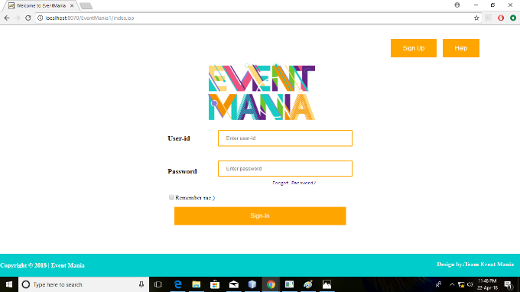 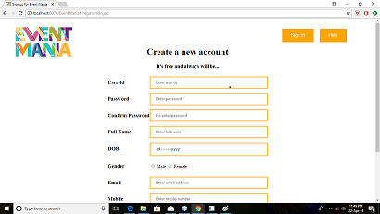

**Module for Login page New registration**

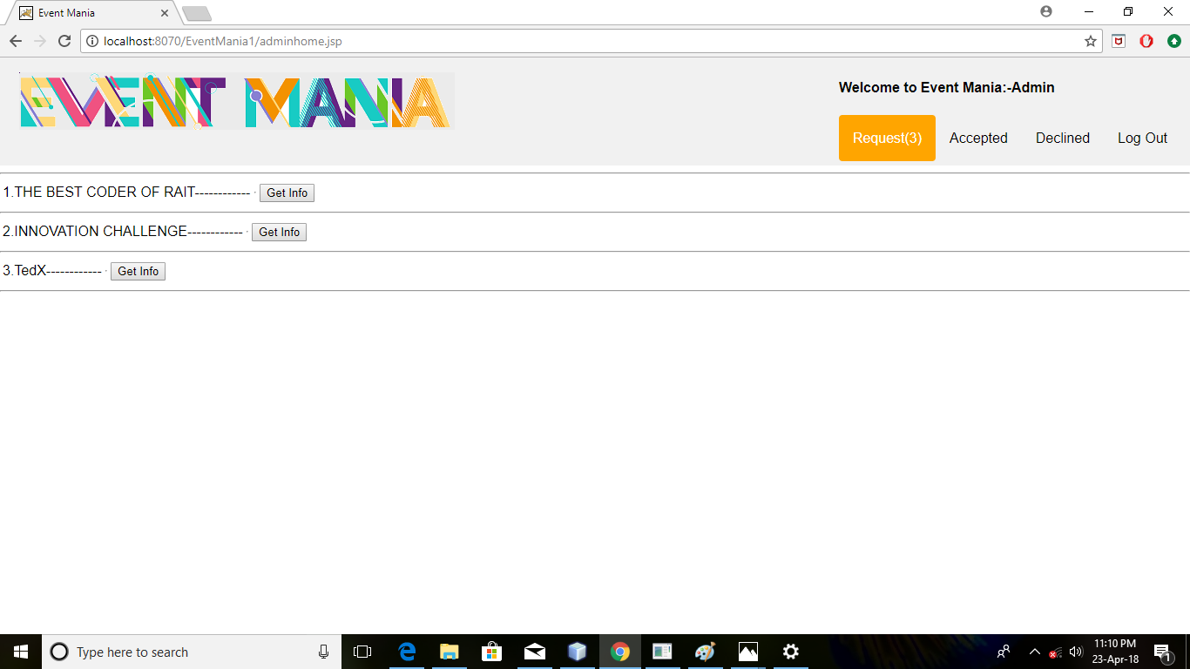

Admin homepage

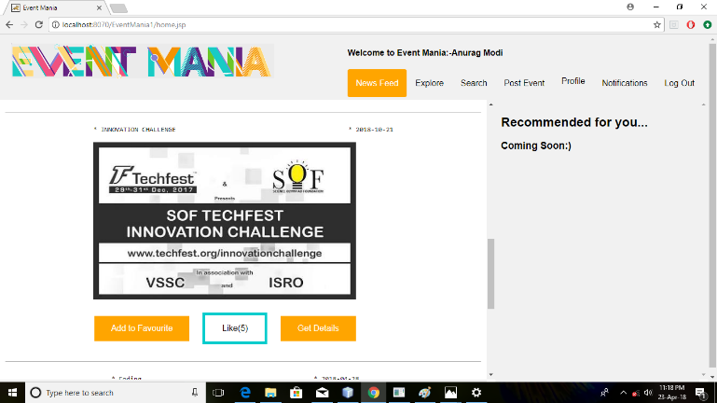

Newsfeed with recommendation

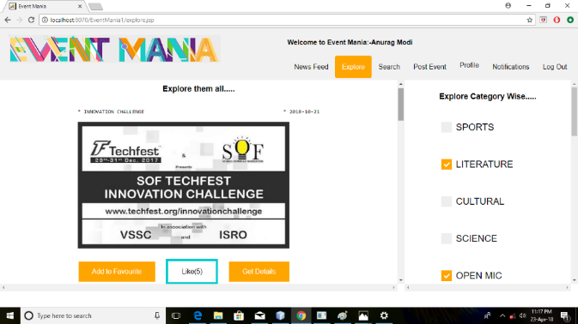

Explore section

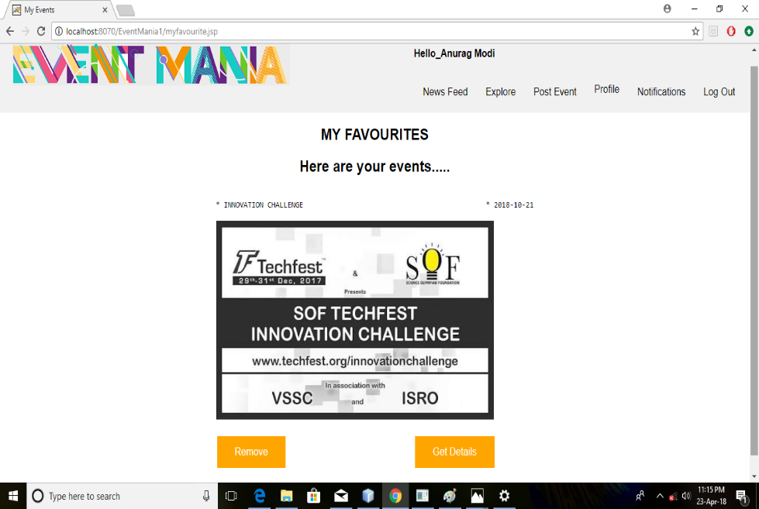

Favorite events all sorted in one page

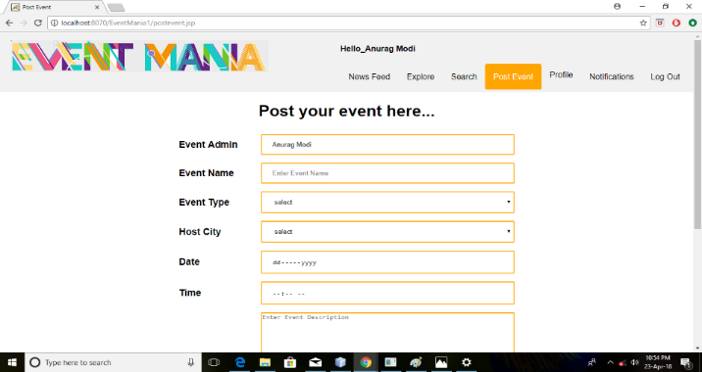

Post your event

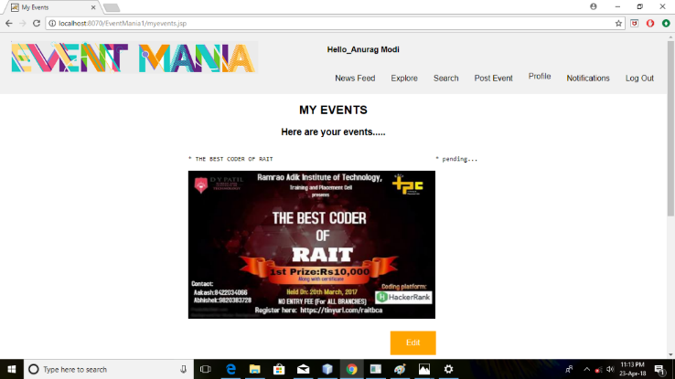

List of events posted

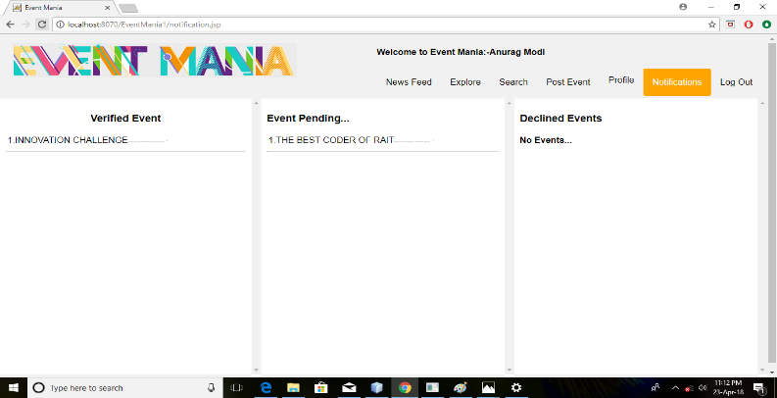

Notification

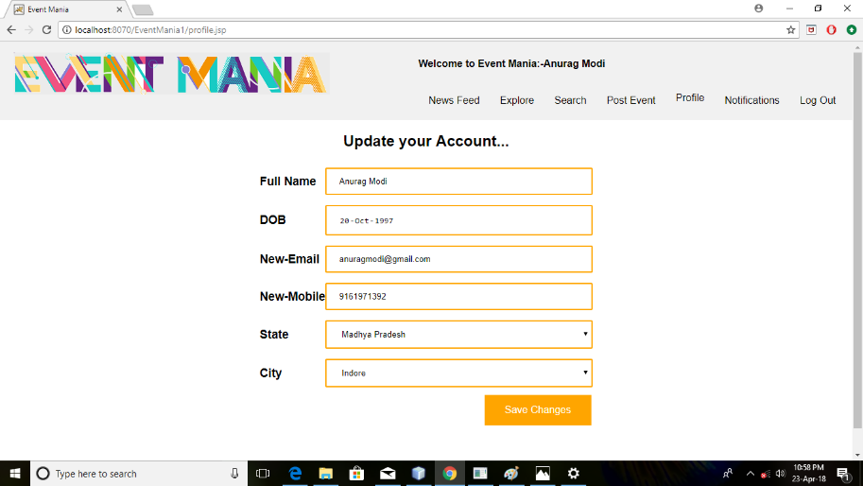

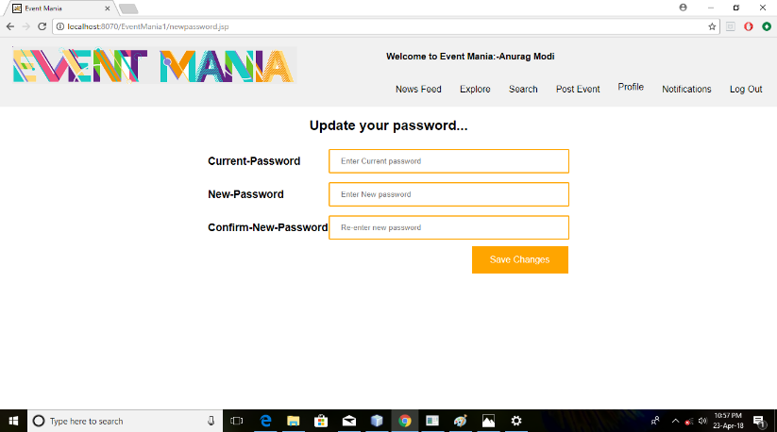

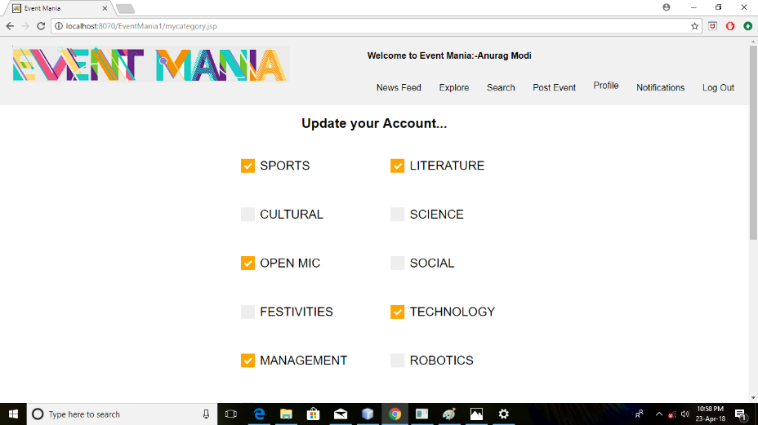

Profile update 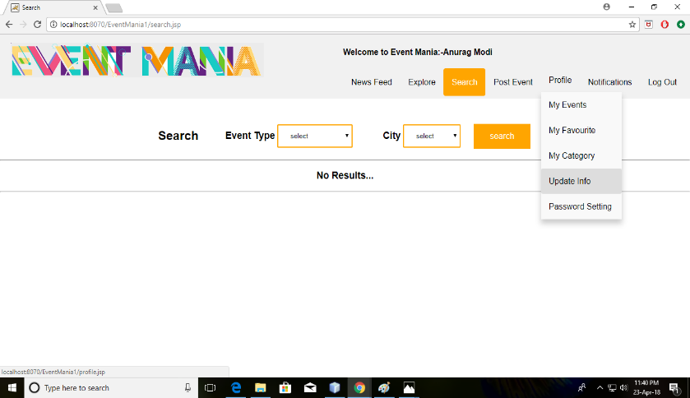

**List of References:**

**Journals:**

[1] D. Walters, G. Sheble, "Genetic Algorithm Solution for Economic Dispatch with Valve Point Loading", *IEEE Transactions on Power Systems*, vol.8, no.3, pp.19-24, 1993.

**Books:**

[1] D.P. Kothari, J.S. Dhillon, *Power System Optimization*, Prentice Hall of India Private Limited, New Delhi, Edition2, pp. 214-221, 2004

**Conferences:**

[1] E.Handschin, L.Muller, T.Nikodem, R.Palma, “Comparison of pricing methodologies for wheeling transactions in liberalised energy supply systems”,Proceedings of *IEEE International Conference* on Electric Utility Deregulation and Restructuring and Power Technologies, pp. 528-531, 4-7 April 2000.

**Reports:**

[1] “Report on the Performance of the State Power Utilities for the Years 2006-08 to 2008-09”, Power Finance Corporation Limited (A Government of India undertaking), New Delhi, September 2010.

**Project Report/Thesis:**

[1] James Daniel Weber, “Implementation of a Newton-Based Optimal Power Flow into a Power System Simulation Environment”, A Thesis submitted to University of Illinois at Urbana-Champaign, pp. 1-102, 1997.

**Website:** [1] “Annual Report (2008-09)”, Central Electricity Regulatory Commission, Government of India, New Delhi, 2010. (Website http://www.cercind.gov.in).

[2] [www.google.com](http://www.google.com/)

[3] www.w3school.com

[4] www.wikipedia.com

1.